**Experiment 2: Operational Amplifiers Experiment Report**

**Title**: Experimental Study on Operational Amplifiers

**Date**: 2024-12-6

**Name**: 徐安博 XU Anbo

**Student Number**: 202283890035

**I. Introduction**

The 741 Operational Amplifier (opamp) is a high gain voltage amplifier with two inputs, Vplus (non-inverting input) and Vminus (inverting input). It has several important properties such as high open - loop gain (Ao approximately equal to 2 times 10 to the power of 5), unity gain bandwidth (B approximately equal to 2 times 10 to the power of 6 Hz), high input impedance (Zi approximately equal to 10 to the power of 6 ohms), and low output impedance (Zo approximately equal to 100 ohms). The output voltage of the op - amp is given by the equation Vo = Ao times (Vplus - Vminus) = Ao times Vd, where Vd is the differential input.

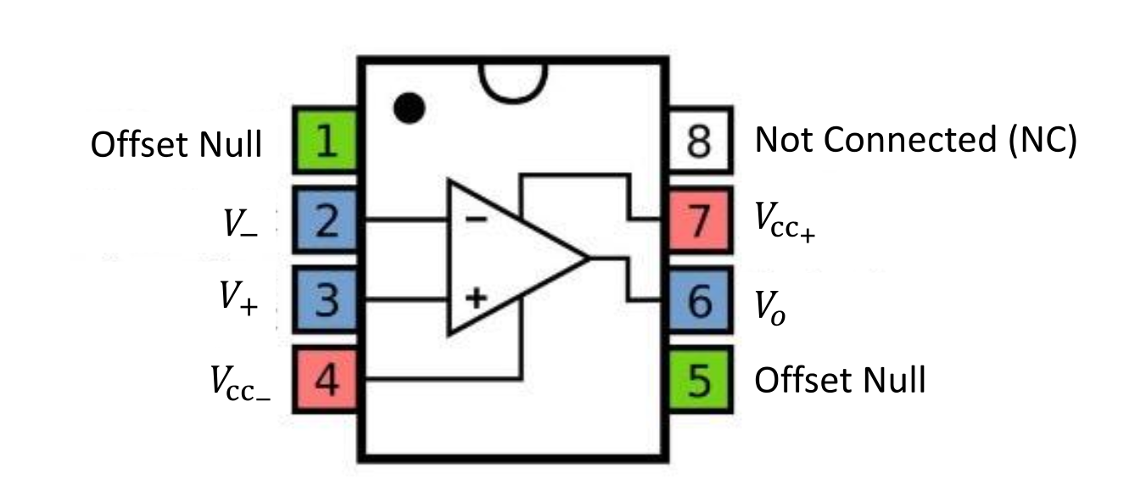

**II. Experimental Procedures and Results**

**Part 1: Non-inverting operational amplifier in open loop configuration**

1. **Experimental Setup**
   * A 12V DC power supply was connected to Pin 7 (+) and Pin 4 (-) of the 741 op amp to power it. The op amp was then connected in an open - loop configuration with a DC power supply providing +5 volts and the circuit grounded appropriately, as shown in Figure 1.
   * Pin 7
   * Pin 3 Pin 6 o V_out + ±12V
   * Pin 2
   * +5V Pin4
   * Figure 1: A 741 op amp in open loop configuration.
2. **Data Measurement and Analysis**
   * The input voltages Vccplus and Vccminus were measured and recorded. The positive saturation voltage was recorded when the input was +5V. Then, the input on Pin 3 was changed to -5V and the negative saturation voltage was recorded. The saturation values were compared to Vccplus and Vccminus. It was observed that at positive saturation, the output voltage approached the maximum positive supply voltage Vccplus, and at negative saturation, it was close to the maximum negative voltage Vccminus. This is due to the very high open loop gain of the amplifier, which results in a very limited linear region. The higher the gain, the larger the slope of the linear region and the closer the line becomes to a vertical.

**Part 2: Negative feedback non-inverting voltage amplifier**

1. **Experimental Setup**
   * The negative feedback non-inverting voltage amplifier circuit was set up as shown in Figure 3. (For simplicity, the power lines for the op amp (Pin 4 and Pin 7) were not shown in the circuit diagram, but the amplifier was powered during the experiment.)
     + o V_out
   * Rf
   * 2.2kQ
   * +5V
   * R_g
   * Figure 3: Non-inverting feedback operational amplifier circuit.
2. **Data Measurement and Analysis**
   * The input voltage from the DC Source was set to 5V. Rg was set to 500 ohms, and the output voltage Vo and the voltage at the inverting terminal Vminus were measured and recorded. Then, Rg was varied between 500 ohms and 100 kΩ to obtain a range of readings to clearly show both the linear and saturation regions of the transfer characteristic. A graph of Rg versus Vout was plotted. Using the formula Av = Vout / Vin, the gain Av of the amplifier was calculated. The voltage transfer characteristic (Vo versus Vi) for this configuration shows an increased linear region due to the reduction in gain. The feedback section, consisting of Rf (a fixed resistor) in series with a variable resistor Rg, allows control over the gain of the amplifier.

**Part 3: Design of a 40 dB non-inverting amplifier**

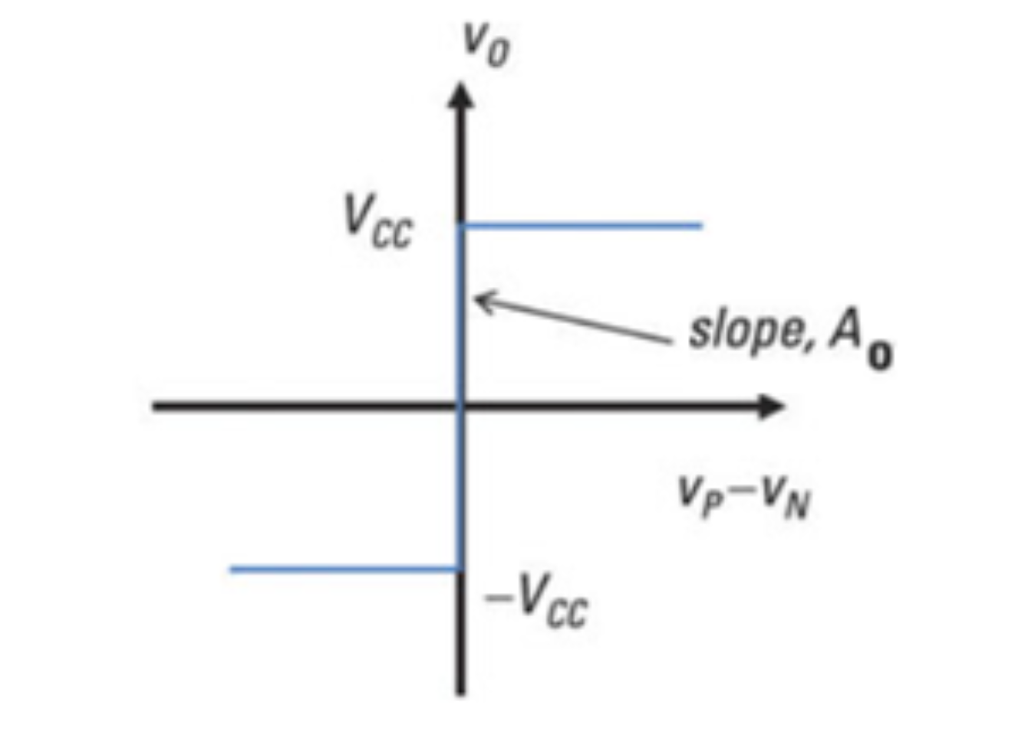

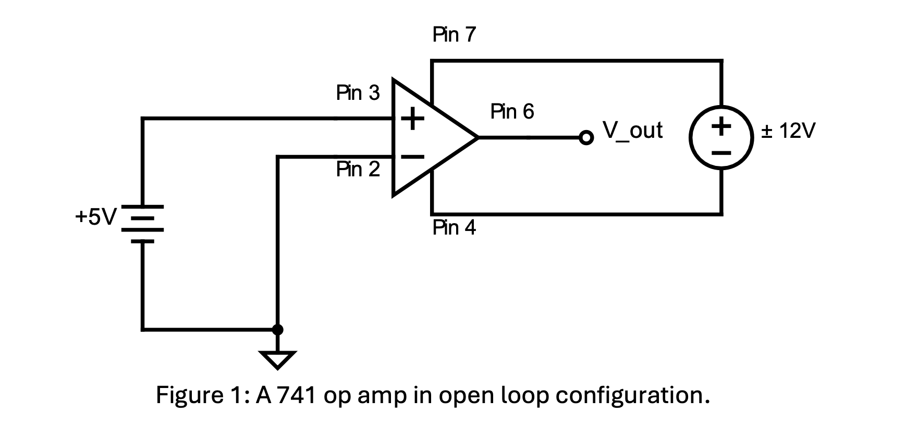

1. **Experimental Setup**
   * The circuit was set up as shown in Figure 4 with a 50 mV input voltage.
   * oV_out
   * 2.2kQ Rf
   * +0.05V
   * Rg
   * Figure 4: Circuit diagram for a non-inverting op - amp with 50 mV input.
2. **Data Measurement and Analysis**
   * Using a DC power supply or signal generator, the input voltage Vi was set to 50 mV. Rg was varied until the gain of the amplifier was 40 dB (i.e., until the measured value of Vout = 5V). A range of Vi and Vo was measured and recorded to clearly show both the linear and saturation regions of the transfer characteristic. As the op amp approached saturation, smaller voltage increases were used to map the curve of the transfer characteristic accurately. A graph of Vi versus Vo was plotted. The goal of this experiment was to achieve precise voltage amplification while maintaining signal integrity and minimizing distortion using an operational amplifier in a non-inverting configuration.

**Part 4: 40 dB Non-Inverting Amplifier Offset Nulling**

1. **Experimental Setup**
   * Using the circuit from Part 3, a 10 kΩ potentiometer was connected across Pin 1 and Pin 5 of the op - amp, and the centre point (Pin 2) of the potentiometer was connected to Vccminus, as shown in Figure 5.
   * +12V Pin 7 Pin 1
   * V+ V_-o O Pin 3 + Pin 6 o V_out
   * Pin 2
   * -12V Pin 4 5 kQ
   * Pin 5
   * Figure 5: Op amp with null offset connected.
2. **Data Measurement and Analysis**
   * With Vi set to 0V, the 10 kΩ potentiometer was varied until Vo = 0V to null the offset caused by imperfections in the operational amplifier. Then, the input terminal was reconnected to the voltage input arrangement. The potentiometer was varied to set Vi to 50 mV, and it was verified that Vo = 5V (i.e., a gain of 100). As in Part 3, the potentiometer was varied, and Vo was measured for a range of Vi and the results were recorded. The input voltage was set to -50 mV by swapping the leads on the power supply, and a graph of Vi versus Vo was plotted. This process aimed to minimize or eliminate the offset to achieve high precision and accurate amplification.

**Part 5: Frequency Response of an Amplifier with a gain of 100**

1. **Experimental Setup**
   * Maintaining the 40 dB gain, a function generator was substituted to drive the input with a sine wave.
2. **Data Measurement and Analysis**
   * The input voltage Vi was set to 50 mV, and the output voltage Vo was measured in the frequency range from 50 Hz to 100 kHz. For each data point, the gain Av was calculated. A graph of f (frequency) versus Av was plotted. The bandwidth of the amplifier was determined using the relationship Gain times Bandwidth = 10 to the power of 6 for a 741 op amp. Then, the gain of the amplifier was reduced to 10, and the measurements were repeated. This experiment explored how the amplifier's gain diminishes as frequency increases and analyzed its performance across a range of frequencies to assess the trade-offs involved and ensure optimal performance within the amplifier's GBW limits.

**Part 6: Simulation of the Frequency Response of an Amplifier**

1. **Simulation Setup**
   * A 40 dB gain amplifier circuit was simulated in Multisim using an AC input. The 3 - terminal Op Amp component was used for simplicity. The model settings of the op - amp component were set as follows: AVOL = 10 k, BW = 10 MHz, RI = 10 MΩ, RO = 100Ω. VOMP and VOMN were set equal to VCCplus and VCCminus respectively as per Part 5.
2. **Data Analysis**
   * Using an AC Sweep, a graph of f versus Av was plotted. The results were compared to those experimentally determined in Part 5. Then, the gain of the amplifier was reduced to 10, and the simulation was repeated. This simulation aimed to compare the theoretical and experimental results and further understand the frequency response characteristics of the amplifier.

**Part 8: Simulation of Differentiation of a Sinusoidal Wave**

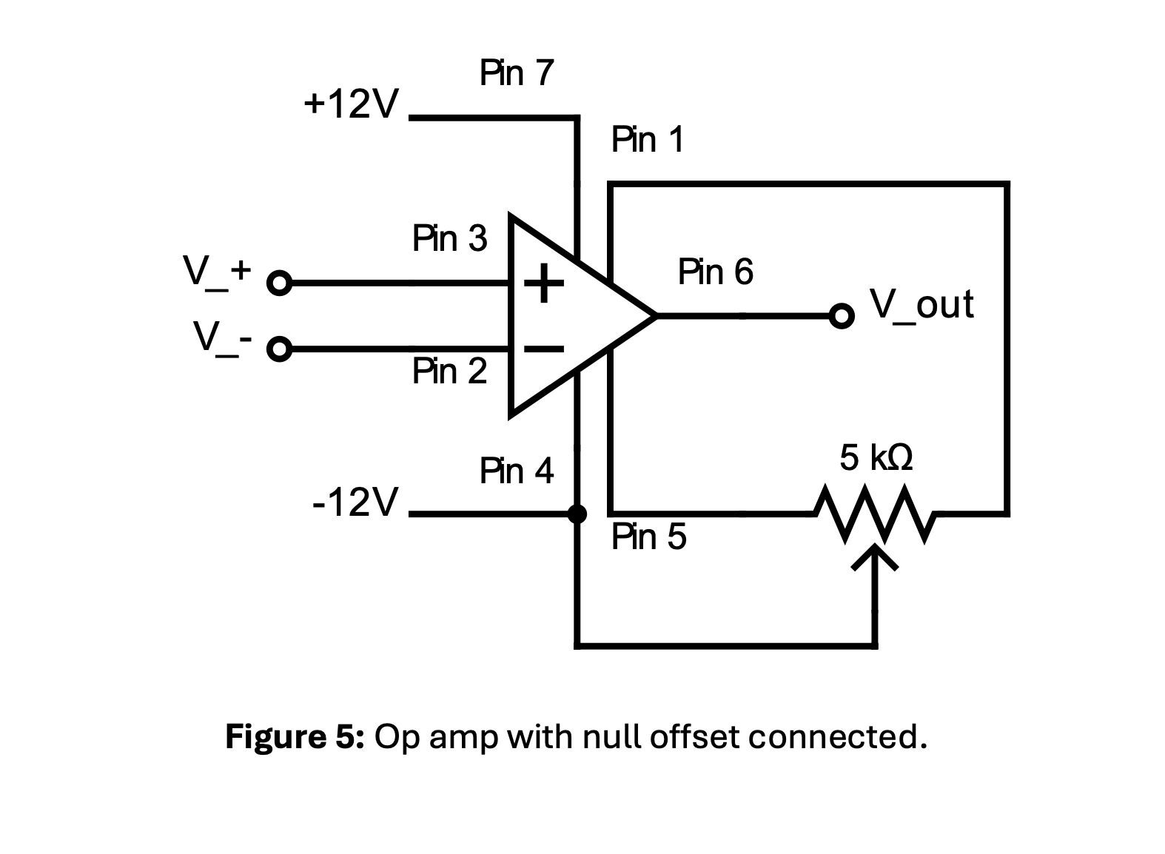

1. **Simulation Procedure**
   * Using Multisim, the equation 2.9x - integral from 0 to 5 of (0.1x + 9x^2)dx was solved. However, the details of the solution and its significance in the context of the overall experiment on operational amplifiers are not entirely clear from the provided information. It may be related to a more advanced analysis or exploration of the capabilities of the simulation software in handling mathematical operations related to the signals in the amplifier circuit.

**III. Conclusion**

Through this series of experiments and simulations on operational amplifiers, we have gained a comprehensive understanding of the characteristics and behaviors of the 741 op amp in different configurations. We have studied its open - loop and closed - loop (with negative feedback) characteristics, including voltage transfer characteristics, gain, saturation voltages, offset nulling, and frequency response. The experimental results and simulations have provided valuable insights into the performance of the op amp and its applications in signal amplification and processing. The knowledge and skills acquired from this experiment will be beneficial for further studies and practical applications in the field of electronics and circuit design.